Emily began her Peace Corps service in Togo, West Africa in June of 2008. She was assigned to the Small Enterprise Development sector. Although she completed many projects over her two years, her main focus was on helping women financially- by providing assistance making their small businesses more profitable or by creating Village Savings & Loans (of which, she started 7) so that women had access to a line of credit.
Drew began his Peace Corps service in September 2008, and did not meet Emily until sometime in 2009. Drew was assigned to the Girls’ Education and Empowerment sector and completed projects teaching girls (and boys) basic life skills, a weekly science club at the village high school, and a regional computer-skills training camp for high school boys and girls.
Here is a picture of Emily and Drew.
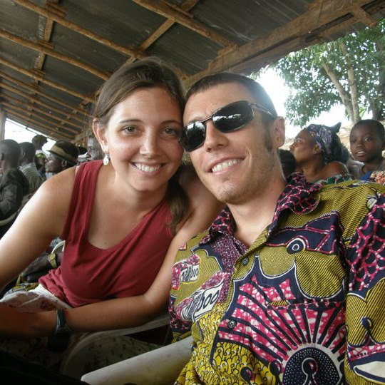
Almost every piece of clothing in Togo comes from one of two places. The first is at a “dead yovo” market. These are clothes that have been given away by Americans and Europeans to organizations like Good Will, who then ship them to Togo. The Dead Yovo market looks like this:
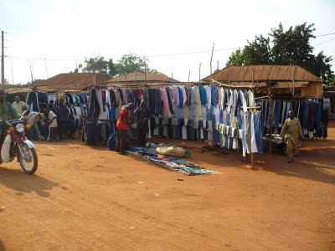
The second is custom-made clothing made from pagne (pronounced “pahn-yuh”), the colorful fabric is sold in the market like in the photo below. After buying some of this fabric, you have to take it to your tailor to have something made. Men usually see a male tailor and women see a woman couturier.
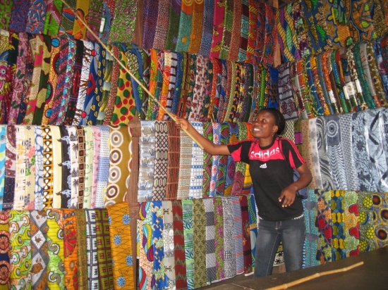
Pagne outfits are viewed more as formal clothing. You would wear a head-to-toe pagne outfit (known as a complet) if you were going to church on Sunday or attending an important event. Below is a photo of Emily at Women’s Day event with a bunch of women from her village, all dressed in their complets.
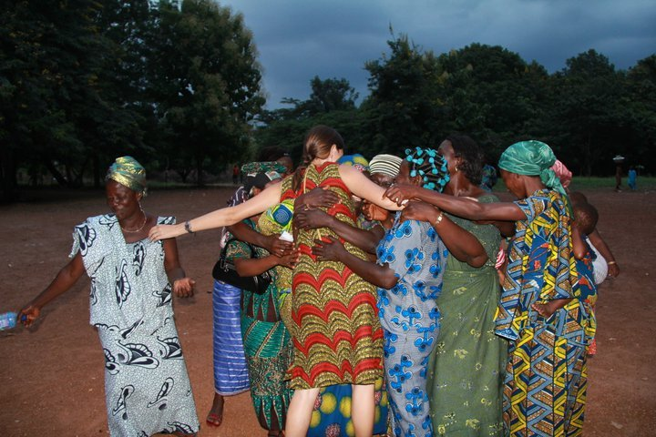
Every time Emily had something made, whether it was a dress, skirt, or pillow cases, she would save the left-over scraps from the pagne fabric with the idea of having a quilt made eventually. She saved scraps for two years- the length of her Peace Corps service. This is a photo of Emily and Maman ADANOU, her host-mother and go-to couturier. Maman ADANOU probably produced the majority of Emily’s clothing (and even some of Drew’s). Here is a picture of Maman ADANOU and Emily posing for a picture; coincidently, Emily is wearing the same dress as above.
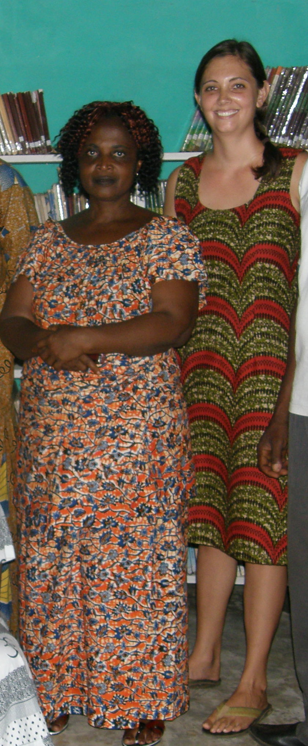
I couldn’t track down any photos of couturiers I know working or even a photo of someone with a sewing machine in the background, so I did a google search and found the following photos. These photos are exactly how tailors and couturiers complete everything they make in Togo.

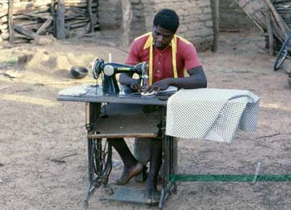
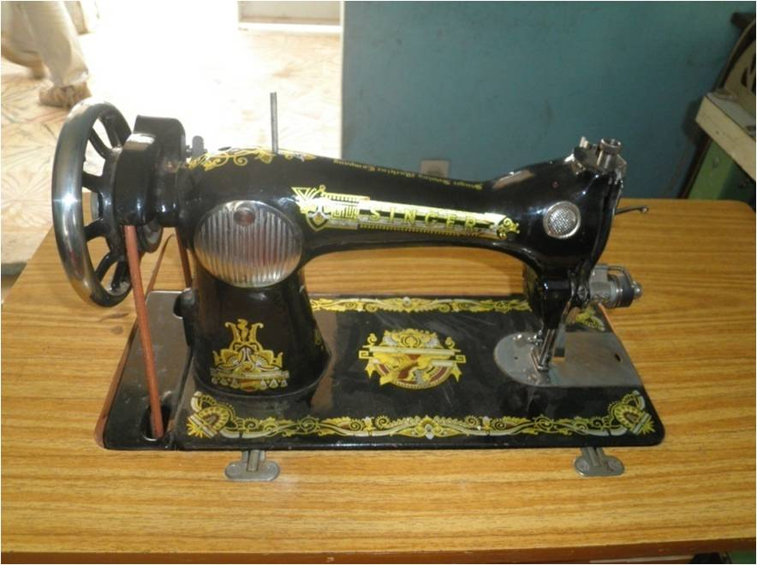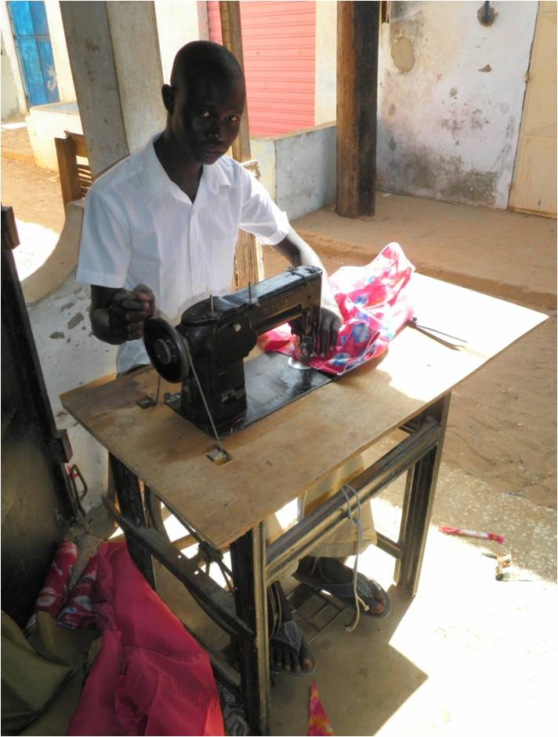

Because she began her service before Drew, Emily finished her service and returned to America first too. Not having had time to organize the bag full of wonky-shaped pagne, and organizing herself to move to another continent, she left the scraps with Drew. Over the month they were separated, Drew took the bag of fabric and cut it up into regular-sized squares and took them to a couturier to have them stitched together.
After returning home, Emily has kept in touch with Maman ADANOU and her family as well as many other friends she made in Togo. She has even started an organization to provide academic loans to the brightest high school students allowing them to go to university, which would otherwise be impossible. You can read more about her organization here: http://tinyurl.com/sukuvi
Because Drew knows nothing about quilts, he sought out some help and was lucky enough to come across Linda’s website. Linda has been extremely helpful in guiding Drew with the critical decisions that need to be made when producing a quilt. When Linda is all finished with the backing, binding and quilting (all of which are terms Drew learned over the last few weeks), Drew will present Emily the quilt on her birthday.
Happy birthday, Emily!

